Employer-supported volunteering and Team days at The Greenhouse

A day at The Greenhouse allows individuals and teams to come and volunteer their time carrying out simple tasks in our gardens, taking time out of normal working routines, seeking life balance and perhaps getting a fresh perspective from spending time in our quiet, reflective spaces such as our meditation gardens and labyrinth.

The Cadbury family, who owned and lived here were Quakers and believed that everyone should be able to access green spaces. We hope that spending a day with us, changing the rhythm of your day, can provide fresh focus to the world around you. You can be around others, in companionship and working alongside one another, whilst not only giving us your valuable time, but also giving valuable time to yourself. We feel that in the smallest of tasks, there is value in the offering; in seeing a different perspective.

Our grounds are maintained by a wonderful group of volunteers. Our Volunteer Coordinator and lead volunteers help corporate and teams of volunteers to get involved various practical activities, depending on the needs of the garden:
- planting, weeding, pruning, including large shrubs.
- Clearing, weeding and preparing garden spaces and delivering small garden projects
- Maintaining pathways, seating areas, and garden structures
- Seasonal work; ie leaf clearing, Clearing fallen branches
- Working alongside other volunteers to deliver small garden projects or events.
- General gardening and maintenance

We will spend the day talking, working, eating together; finding achievements in the simple, practical tasks achieved together. There is also an opportunity to spend time out in either guided or personal reflection during the day and find out more about the work of The Greenhouse.

Why come to The Greenhouse?
- Give your teams the opportunity to step out of their routines to reset and re-energise them as individuals and a team.
- Spending the day with us is a great way to boost employee wellbeing. Well-being, peace and reconciliation within ourselves is important at The Greenhouse and part of our Quaker and Celtic heritage.
- Volunteer garden days encourage individuals and teams to communicate and collaborate and spend quality time with one another outside of their normal roles.
- Time outdoors, physical activity, fresh air and doing something purposeful can provide a welcome break from the desk and day-to-day pressures of work
- Gives employees the chance to spend time together, be active and contribute to something positive.
We have a friendly and informal environment. You don't need any experience, and we will adapt and be inclusive of individual needs and abilities. We provide all equipment and guidance. Just bring your enthusiasm.

The best team experiences are the ones people remember, you will remember leaving the ‘busy’ behind as you drive through our gates, you will remember the achievement of physical work and of time spent together.

There is a small cost per volunteer for the day of £15.00 for the costs of the day and work of the Greenhouse. Minimum booking of 5 persons.

On the day
We are looking forward to your visit and for work colleagues to volunteer with us at The Greenhouse at Barnes Close. You are very welcome, we hope you have a good day with us. We hope you have opportunities to reconnect with colleagues as well as opportunities to reconnect with yourself.

Our gardens are entirely maintained by volunteers and days are primarily led by lead volunteers and the Volunteer Coordinator who direct projects and tasks for team volunteer days and regular Monthly Volunteer days. If you are here on a regular volunteer day there may be other volunteers here on these days too.

We start at 10.30am and finish around 3.30 – 4pm. Please arrive after 10am. If you can’t already see us outside, please ring the front doorbell and come inside to reception, someone will come and see you.

We stop for lunch together at 12.00 and at the sound of the bell you are invited to join us for lunchtime reflections (suitable for all faiths and non) at 12.30. Please join us in the chapel or take the opportunity to spend time on your own around the house and gardens.
We want you to benefit from being with us, whilst we receive your effort and time, we hope that you will receive a sense of this place, and benefit from the peace here. We encourage you to visit our Meditation area and Prayer labyrinth and meet Joey and Chino our Alpacas!

Our volunteer chaplain is often available, as is our Centre Director. Rev Helen Lawson.

What to bring
Please dress appropriately for outdoor garden tasks, including sturdy shoes due to uneven ground on site. Consider the weather, if it’s raining, wear waterproofs (although we will have a rainy-day alternative plan!), if it's sunny you might want to consider sun protection; hat, lotion, long sleeves etc. You do not need to bring any equipment with you, unless you have a favourite trowel! All equipment is provided, and we have gloves for everyone.

Bring a packed lunch as we are not close to any shops to purchase lunch. We will supply hot and cold drinks and biscuits!

Please can you complete the one-off volunteering form and bring that with you on the day.

Health and safety information
Please read and follow the following safety advice.
- Follow instructions. Please follow instructions given to you about tasks you are given by staff and lead volunteers who will make themselves known to you. Please don’t attempt work that hasn’t been assigned to you.
- Wear gloves. Please wear gloves to help avoid any allergic reactions. Please notify staff of any allergies or medication needs at the start of the session.
- Hot weather. Please seek shade, if necessary, wear a hat and drink plenty of fluids and take breaks. Shelter available inside. Please wear any sunscreen/protection as needed. We do have some sunscreen available in the first aid kit, if you have allergies or sensitive skin, you should always bring your own.
- Shed and equipment store. Only staff and select volunteers should go into these areas, if you need something from there do not go in, please ask staff.
- Uneven ground. The grounds around The Greenhouse are uneven. There may be fallen trees and branches around. Be aware of your surroundings and wear suitable footwear.
- Pond and stream area. Please do not work on your own by the pond and stream, always have someone with you.
- Use of tools. Staff will advise of safe tool use (as needed). Please ask for further instruction in tool use if you are uncertain. Please always make sure you place and store equipment correctly to avoid accidents.
- Sharp tools. Tools with sharp ends will be given by staff/lead volunteer to an individual to take responsibility for. They should ensure it is used and kept safely and not passed into general use. It should be handed back to the staff member when finished with.
- Use of power tools. We will not often use power tools, and only by experienced and trained volunteers. Please make sure you keep a good safe distance from where power tools are being used.
- Heavy loads, wheelbarrows, full trugs, logs and stones. Please do not to carry excessive loads. Use wheelbarrows or share the load with another person. Drag or roll heavy logs.
- Wash your hands. Everyone must wash their hands thoroughly after working in the grounds and before handling food and drink. Please cover any cuts or abrasions before garden sessions. Ask staff for plasters etc as needed.
- Outside toilet. We have an outside toilet and sink at the top of the drive on the left as you reach the house.
- Fire notice. In case of fire or on hearing the fire alarm from the house, please make your way to the main car park, following any instructions from staff.

How to get to us

By road
- 5 Minutes from the M5 Motorway by Car
- Exit M5 at Junction 4 taking the A491 exit to A38 (B’ham (SW) Stourbridge)
- At Lydiate Ash Interchange roundabout, take the 1st exit onto Sandy Lane (A491)
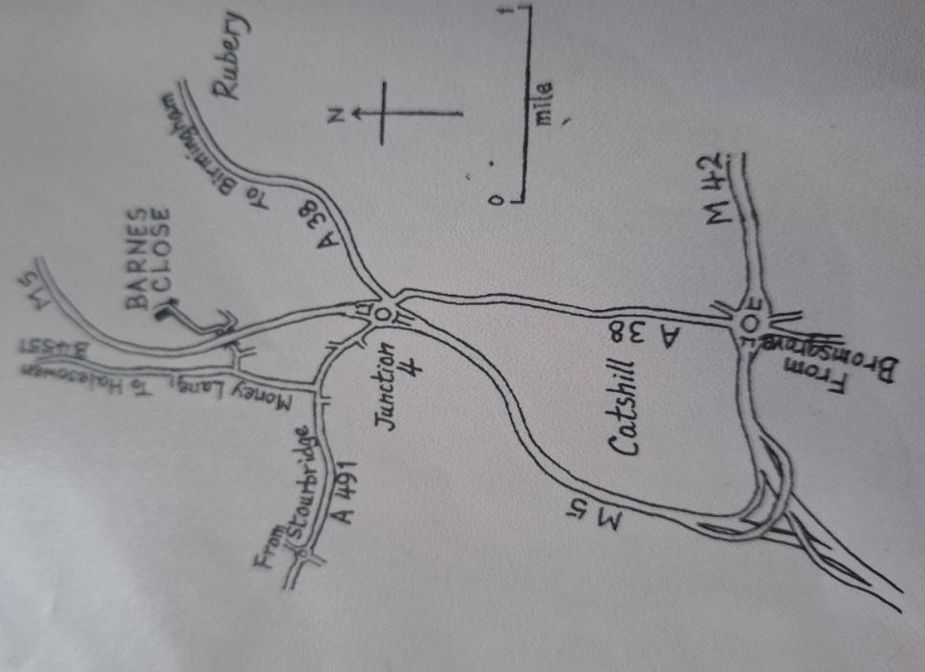
- Turn right onto Money Lane (B4551) signposted for Waseley Hill Country Park.
- Turn right onto Malthouse Lane
- Take the first left and follow the road under the tunnel
- Turn left and follow the private road until you come to The Greenhouse at Barnes Close gate and entrance.

Parking
To access parking follow the drive up to the house, continue to drive behind the side of the house to the left, where you will find parking space for up to 20 or so cars.

Nearby Train Stations
- Longbridge Station (9 min / 4.9 miles)
- Barnt Green Station (10 min / 4.6 miles)
- Bromsgrove Station (12 min / 6 miles)

Contact us and come again
If you have any queries about visiting and volunteering, please get in contact. If you are interested in becoming a regular Greenhouse Volunteer, we meet on the second Monday every month, and once a month on a Sunday afternoon from 12 onwards until we finish for tea and cake at 3.30pm. We would love to see you there.
The Greenhouse at Barnes Close, Chadwich Manor Estate, Bromsgrove, Worcestershire, B61 0RA.
t. 01562 710278
e. volunteering@greenhouseatbarnesclose.org.uk
w. www.greenhouseatbarnesclose.org.uk

