How to find us

By road
- 5 Minutes from the M5 Motorway by Car
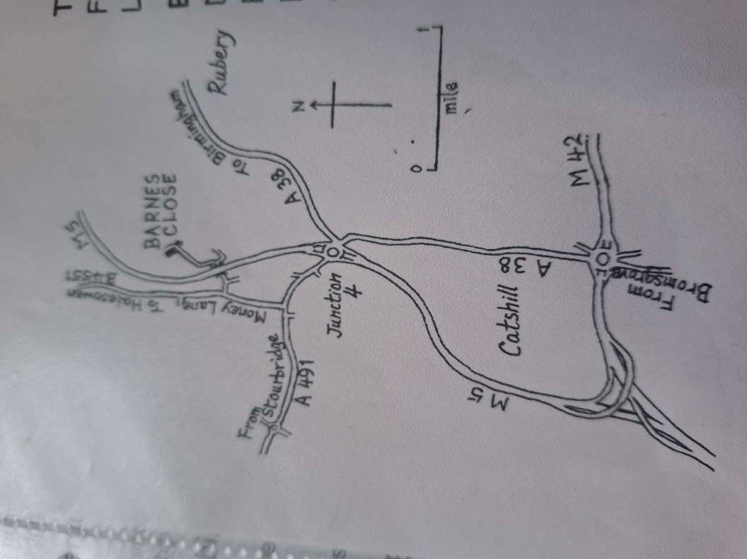
- Exit M5 at Junction 4 taking the A491 exit to A38 (B’ham (SW) Stourbridge)
- At Lydiate Ash Interchange roundabout, take the 1st exit onto Sandy Lane (A491)
- Turn right onto Money Lane (B4551) signposted for Waseley Hill Country Park.
- Turn right onto Malthouse Lane
- Take the first left and follow the road under the tunnel
- Turn left and follow the private road until you come to The Greenhouse at Barnes Close gate and entrance.

Nearby Train Stations
- Longbridge Station (9 min / 4.9 miles)
- Barnt Green Station (10 min / 4.6 miles)
- Bromsgrove Station (12 min / 6 miles)

Contact us
The Greenhouse at Barnes Close, Chadwich Manor Estate, Bromsgrove, Worcestershire, B61 0RA.
t. 01562 710278
e. volunteering@greenhouseatbarnesclose.org.uk
w. www.greenhouseatbarnesclose.org.uk

